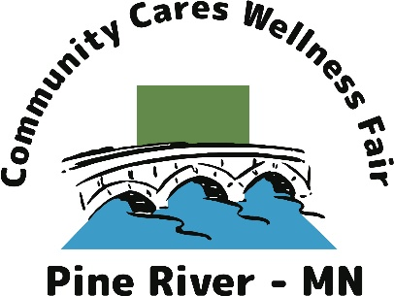

Community Cares Wellness Fair
Resource Booth Form
The Pine River-Backus Family Center is partnering with local agencies to promote a Wellness Fair at the Cass County Fairgrounds in Pine River on August 19th from 9:00am to 3:00pm. The event is supported by Northern Pines Mental Health Center, Cass County SHIP, Happy Dancing Turtle, and Head Start. The Community Cares Wellness Fair aims to:

“Showcase and highlight health and wellness resources available to all ages in our area and provide onsite, hands on, screenings and other health and wellness related services.”

During this event participants will be encouraged to visit all booths and collect stickers in order to be entered into a door prize drawing, hopefully increasing your interactions with potential learners. Wellness presentations will also be featured periodically as the day unfolds. Please let us know if you have an idea for an interesting and engaging presentation.

Resource Booth Information:
Cost of Booth: $50 or a door prize to the value of at least $50.
- All Resource Booths will be mentioned in the Community Cares event program.
- A 10x10 space will be available.
- Electric Hook will be available for early registrants (please indicate below).
- Vendors may not sell any products or services during this fair (free demos and samples are allowed).
- Set-up can begin at 7:00am - takedown any time after 3:00pm
- The organizing committee will accept booths with health and wellness resources that are in line with funding and group goals.
- Resource Booth Registrants will be responsible for providing their own table and chairs.

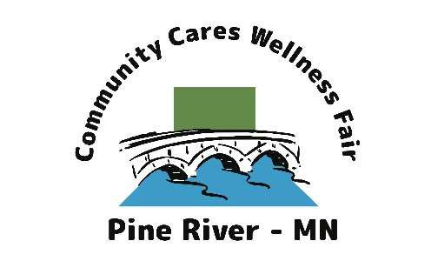
Resource Booth Application:

Name of Company or Organization: ___________________________________
Contact Person/Position: ___________________________________
Contact Person Information: phone: ____________ email: _________________

Name of Booth/Product/Service: _______________________________________
Description of what your booth will offer: ______________________________________________________________________________________________________________________________________
Door Prize or $50 fee? Door Prize ____ $50 _____
Electrical Hook Up Needed: yes____ no____
Idea for a Presentation: yes___ Idea: _____________________________
___________________________________________________________________
Two ways to Register:
- Online here: https://fs30.formsite.com/happydancingturtle/dtwei45jry/index
Payments only accepted by check and can be made out to “Pine River-Backus Family Center”.
- Return this form with payment to
CCWF, c/o LuAnn Gravelle, PO Box 1, Pine River, MN 56474
(Tel: 218-587-4292)

For more information or questions please call:
Nicki Linsten-Lodge: 218-606-2816 or Destiny Brown: 218-821-2501

