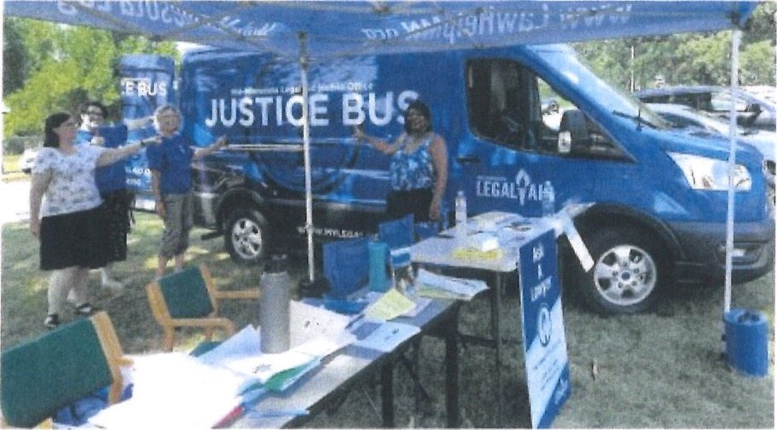
FREE LEGAL HELP
The Justice Bus is coming to the

PINE RIVER AREA FOOD SHELF

On March 19, 2024, from 10 a.m. to 1 p.m., the Justice Bus will be at the Pine River Area Food Shelf, 245 Barclay Ave., Pine River. Justice Buses are mobile legal aid offices that travel to rural areas.

If you are 60 years or older and reside in Cass County, you can get free help with legal problems involving Medicare, Social Security, eviction or other housing problems, public benefits, such as medical assistance, food support, fuel assistance, family law issues (i.e. domestic abuse), income maintenance, nursing home problems, home care services, powers of attorney, health care directives, or debt collection. NO help is provided for criminal matters, wills, estate planning, or real estate transactions.

If you have any questions, please call our office at
1-888-360-2889.

